Neural Network Assignment -1
Name = Hema Rajput
Roll no = 24UADS1062

Q1. WAP to visualize the Perceptron Learning Algorithm using numpy and matplotlib/seaborn in Python. Evaluate performance of a single perceptron for NAND and XOR truth tables as input dataset.
NAND perceptron code :
import numpy as np
import matplotlib.pyplot as plt
import time

# ---------------- DATA ----------------
X = np.array([
[0, 0],
[0, 1],
[1, 0],
[1, 1]
])

y = np.array([1, 1, 1, 0]) # NAND output

# ---------------- PARAMETERS ----------------
w = np.array([0.0, 0.0])
b = 0.0
lr = 0.1
epochs = 6

errors_epoch = []
accuracy_epoch = []

plt.ion()

# ---------------- STEP FUNCTION ----------------
def step(x):
return 1 if x >= 0 else 0

# ---------------- TRAINING ----------------
for epoch in range(epochs):
total_error = 0
correct = 0

print(f"\nEpoch {epoch + 1}")
print("X1 X2 | Target | Pred | Error | Weights | Bias")
print("-" * 60)

preds = []

for i in range(len(X)):
z = np.dot(X[i], w) + b
y_pred = step(z)
error = y[i] - y_pred

w = w + lr * error * X[i]
b = b + lr * error

total_error += abs(error)
preds.append(y_pred)

if y_pred == y[i]:
correct += 1

print(f"{X[i][0]} {X[i][1]} | {y[i]} | {y_pred} | {error} | {w} | {b}")

# Accuracy
accuracy = (correct / len(X)) * 100
accuracy_epoch.append(accuracy)
errors_epoch.append(total_error)

print(f"Accuracy: {accuracy:.2f}%")

# ---------------- PLOT ----------------
plt.clf()
for i in range(len(X)):
if preds[i] == y[i]:
plt.scatter(X[i][0], X[i][1], c='green', marker='o', s=120)
else:
plt.scatter(X[i][0], X[i][1], c='orange', marker='^', s=120)

x_vals = np.array([-0.5, 1.5])
if w[1] != 0:
y_vals = -(w[0] * x_vals + b) / w[1]
plt.plot(x_vals, y_vals, color='purple', linestyle='--')

plt.title(f"NAND Gate - Epoch {epoch + 1}")
plt.xlabel("X1")
plt.ylabel("X2")
plt.grid()
plt.xlim(-0.5, 1.5) # Set x-axis limits to keep origin visible and consistent
plt.ylim(-0.5, 1.5) # Set y-axis limits to keep origin visible and consistent
plt.pause(2)

if total_error == 0:
print("\n✔ Converged!")
break

plt.ioff()

# ---------------- ERROR GRAPH ----------------
plt.figure()
plt.plot(errors_epoch, marker='o', color='blue')
plt.title("NAND Error vs Epoch")
plt.xlabel("Epoch")
plt.ylabel("Total Error")
plt.grid()
plt.show()

# ---------------- ACCURACY GRAPH ----------------
plt.figure()
plt.plot(accuracy_epoch, marker='s', color='red')
plt.title("Accuracy vs Epoch")
plt.xlabel("Epoch")
plt.ylabel("Accuracy (%)")
plt.ylim(0, 105)
plt.grid()
plt.show()

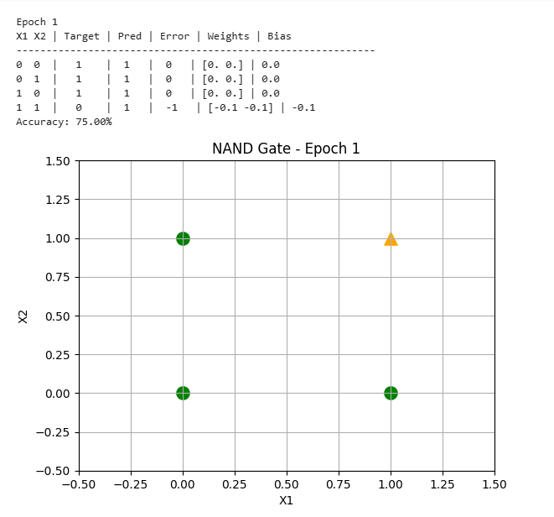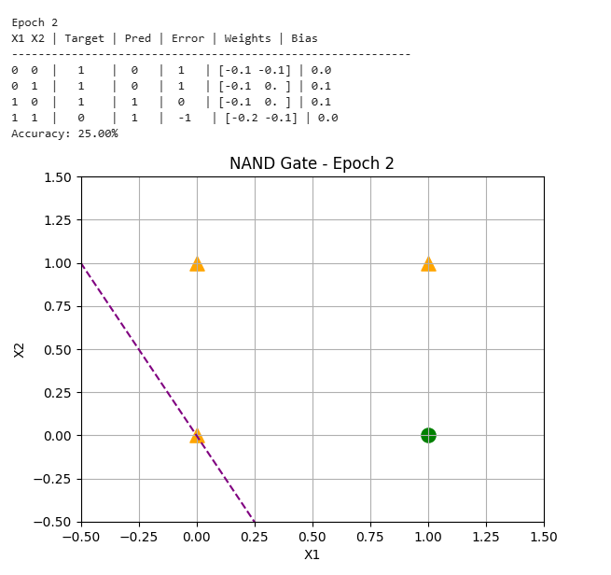
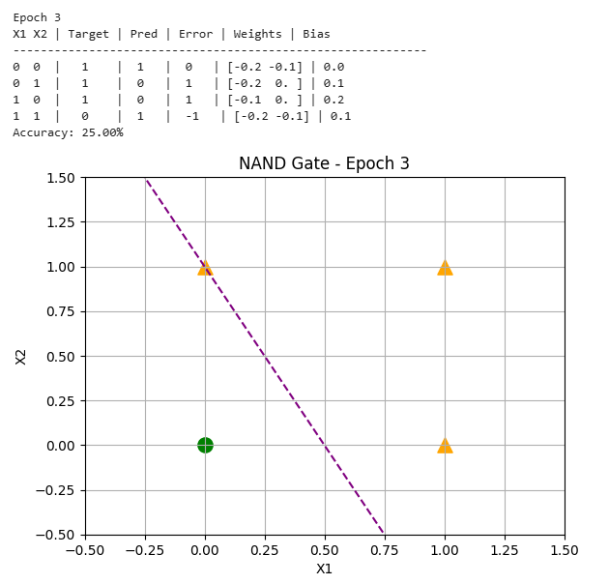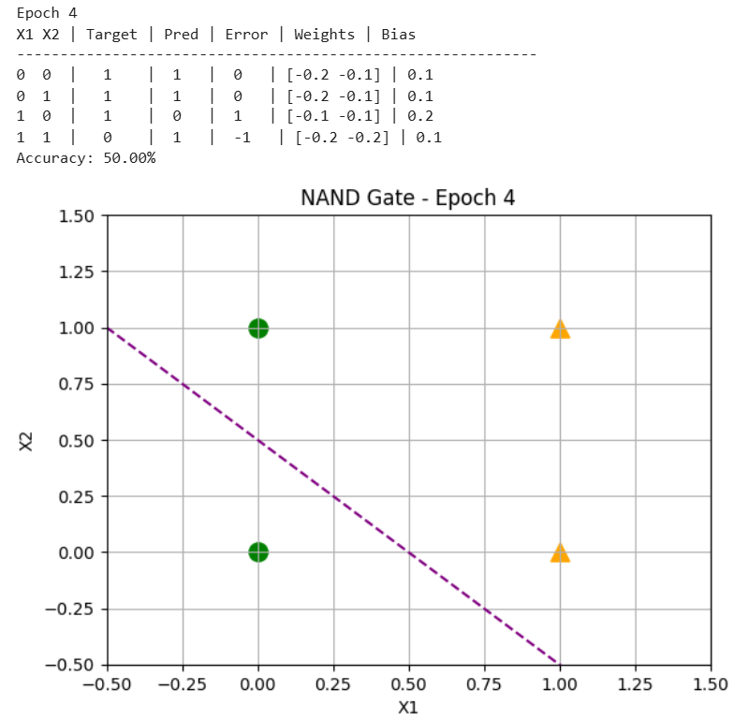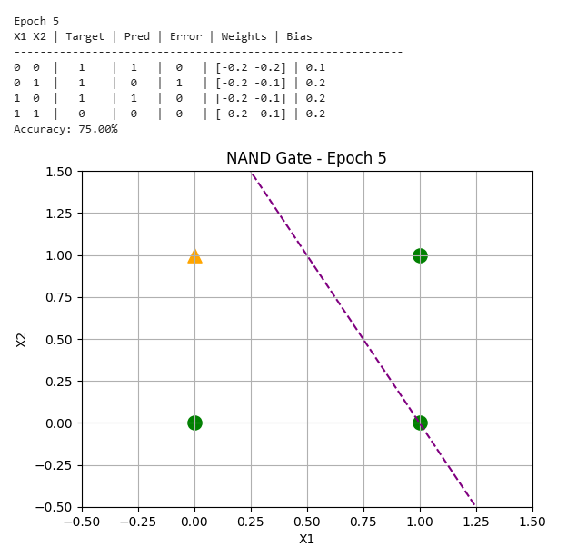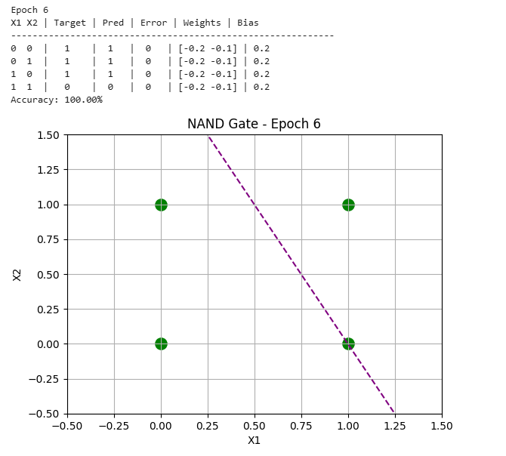
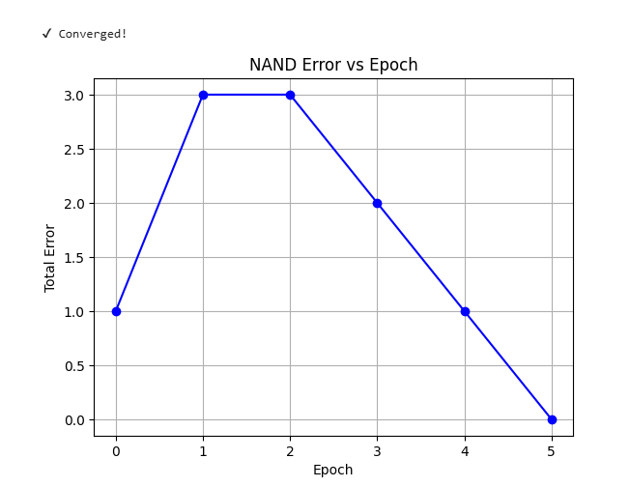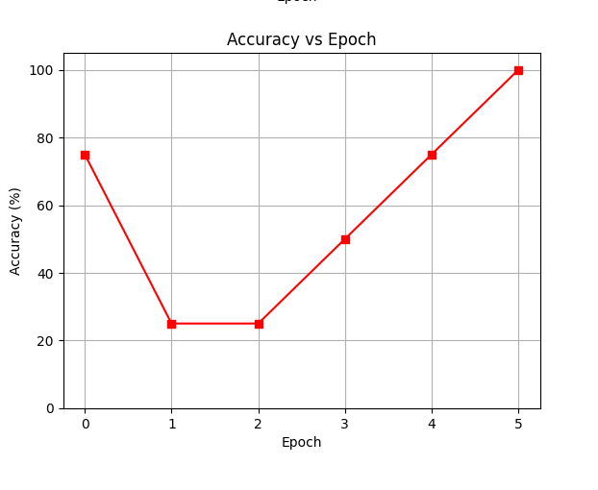
#comments :
What I learned from this code:
In the NAND code I learned how a single layer perceptron work and how it solve linearly separable logic gate like NAND And how input value of weight bias and learning rate together make prediction in this code I also learn about the step function and how value convert into binary output and I also use numpy for perform dot product calculation and matplotlib for visualize and I also see how boundary change after each epoch

Problems I faced:
First I think why the weight and bias is not updating correctly and why my output is wrong and I also don't understand how the error is calculated and how it affects my weight update and major problem I was visualise that how perceptron separate data point using the straight line

XOR perceptron code :
import numpy as np
import matplotlib.pyplot as plt
import time

# -----------------------------
# XOR Dataset
# -----------------------------
X = np.array([
[0, 0],
[0, 1],
[1, 0],
[1, 1]
])
y = np.array([0, 1, 1, 0])

# -----------------------------
# Initialization
# -----------------------------
weights = np.array([0.0, 0.0])
bias = 0.0
learning_rate = 0.1
epochs = 20

total_errors = []
accuracies = []

# -----------------------------
# Activation Function
# -----------------------------
def step_function(z):
return 1 if z >= 0 else 0

plt.ion()

# -----------------------------
# Training
# -----------------------------
for epoch in range(epochs):
total_error = 0
correct = 0

print(f"\nEpoch {epoch + 1}")
print("X1 X2 | Target | Predicted | Error | Weights | Bias")
print("-" * 70)

predictions = []

# -------- Training pass --------
for i in range(len(X)):
net = np.dot(weights, X[i]) + bias
pred = step_function(net)
error = y[i] - pred

weights += learning_rate * error * X[i]
bias += learning_rate * error

total_error += abs(error)
predictions.append(pred)

if pred == y[i]:
correct += 1

print(f"{X[i][0]} {X[i][1]} | {y[i]} | {pred} | {error} | {weights} | {bias:.2f}")

accuracy = correct / len(X)
accuracies.append(accuracy)
total_errors.append(total_error)

print(f"Total Error: {total_error}")
print(f"Accuracy: {accuracy * 100:.2f}%")

# -------- Visualization --------
plt.clf()

# Actual points
for i in range(len(X)):
if y[i] == 1:
plt.scatter(X[i][0], X[i][1], c='green', s=120, label='Actual 1' if i == 1 else "")
else:
plt.scatter(X[i][0], X[i][1], c='red', s=120, label='Actual 0' if i == 0 else "")

# Predicted points
for i in range(len(X)):
plt.scatter(X[i][0], X[i][1],
marker='x',
s=120,
c='blue' if predictions[i] == 1 else 'black',
label='Predicted' if i == 0 else "")

# Decision Boundary
x_vals = np.linspace(-0.2, 1.2, 200)
if abs(weights[1]) > 1e-6:
y_vals = -(weights[0] * x_vals + bias) / weights[1]
plt.plot(x_vals, y_vals, 'b-', linewidth=2, label='Decision Boundary')
elif abs(weights[0]) > 1e-6:
plt.axvline(x=-bias / weights[0], color='b', linewidth=2)
else:
plt.text(0.5, 0.5, "No valid boundary", ha='center')

plt.xlim(-0.2, 1.2)
plt.ylim(-0.2, 1.2)
plt.xlabel("X1")
plt.ylabel("X2")
plt.title(f"XOR Perceptron - Epoch {epoch + 1}")
plt.grid(True)
plt.legend()
plt.pause(1)

plt.ioff()

# -----------------------------
# Error vs Epoch
# -----------------------------
plt.figure()
plt.plot(range(1, epochs + 1), total_errors, marker='o')
plt.xlabel("Epoch")
plt.ylabel("Total Error")
plt.title("Total Error vs Epochs (XOR)")
plt.grid(True)
plt.show()

# -----------------------------
# Accuracy vs Epoch
# -----------------------------
plt.figure()
plt.plot(range(1, epochs + 1), accuracies, marker='o')
plt.xlabel("Epoch")
plt.ylabel("Accuracy")
plt.title("Accuracy vs Epochs (XOR)")
plt.grid(True)
plt.show()

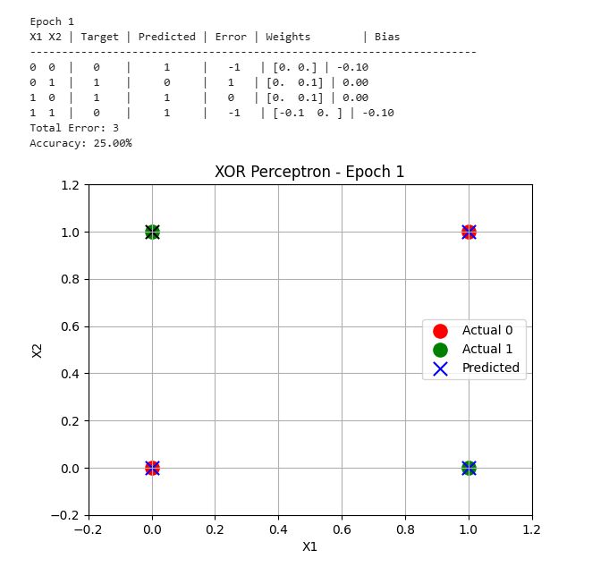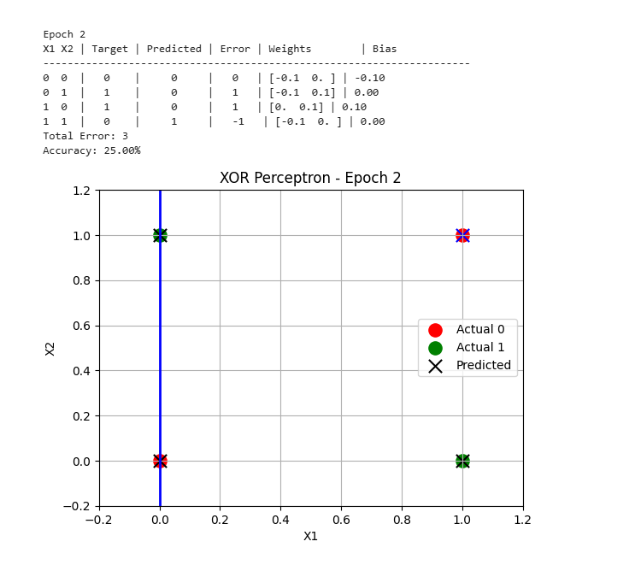

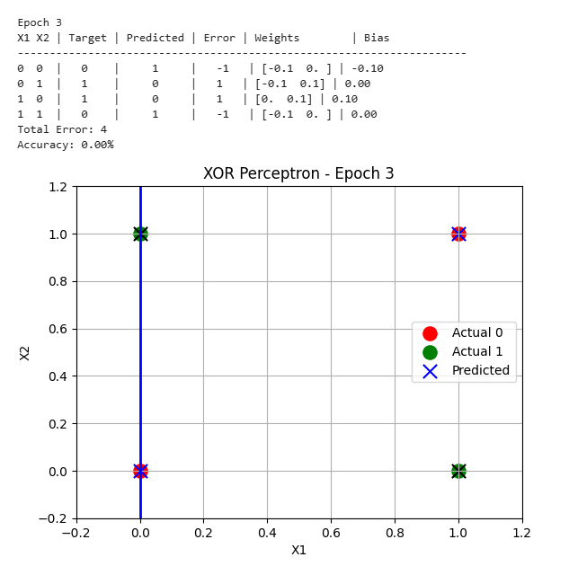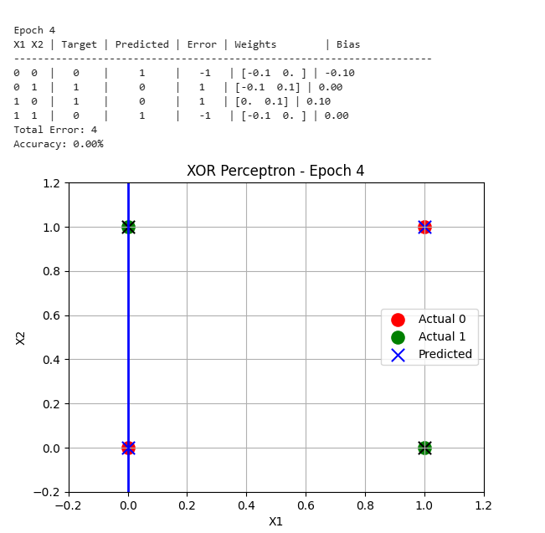
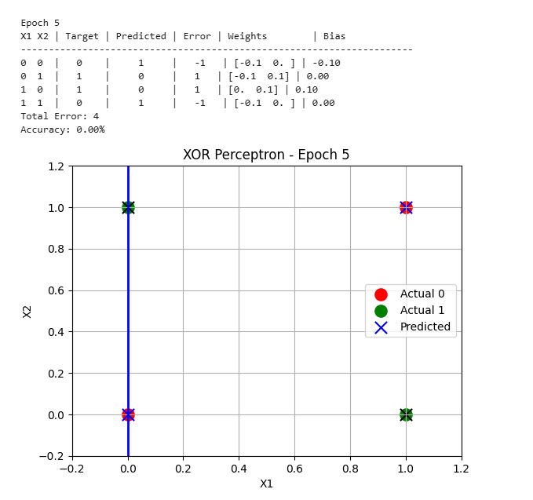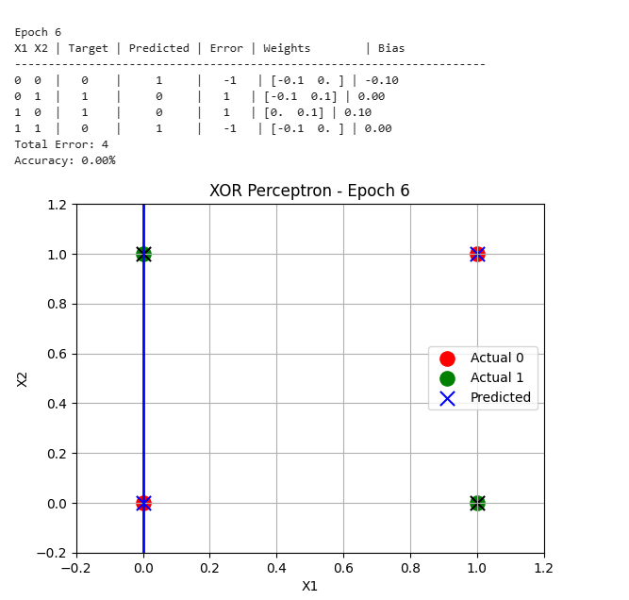
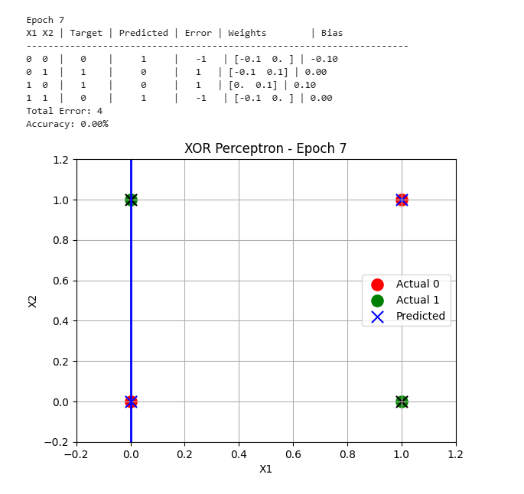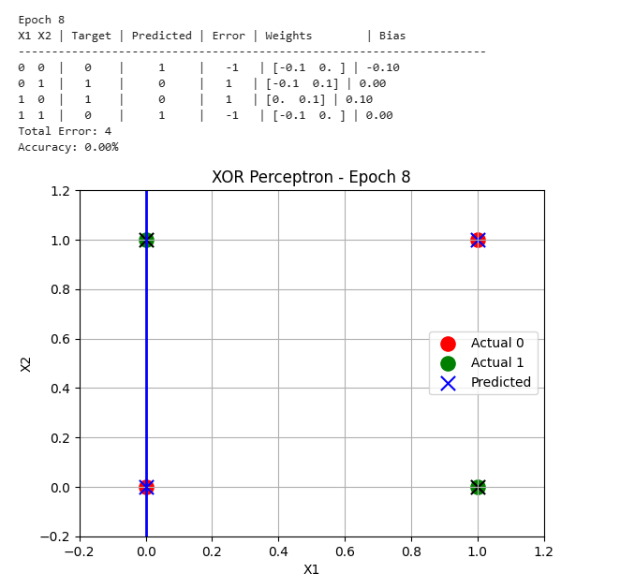
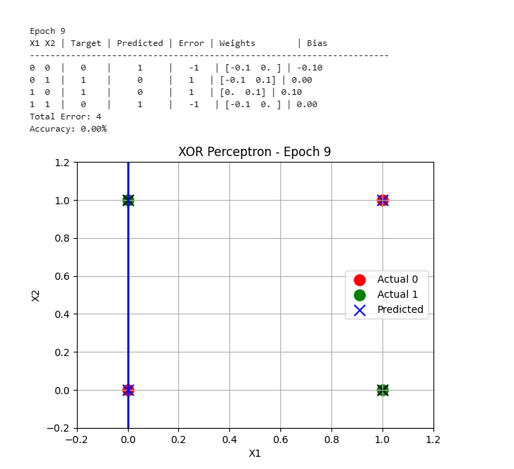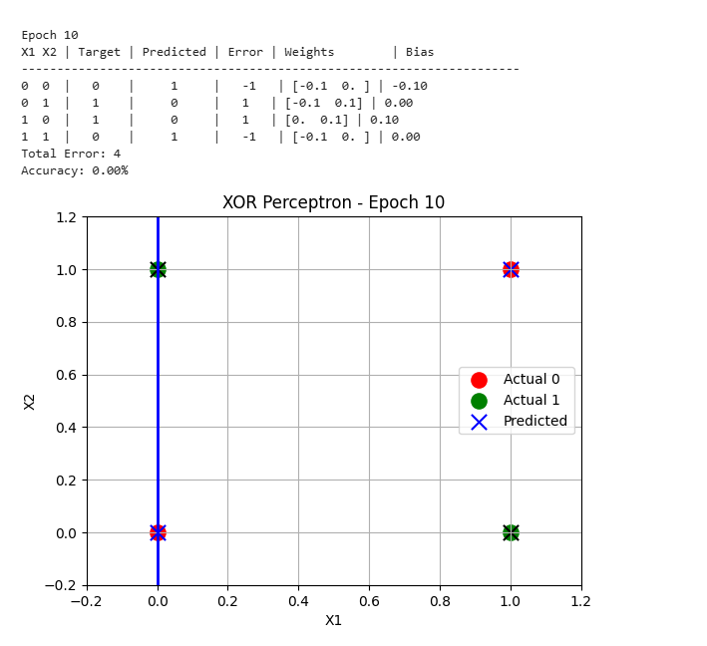
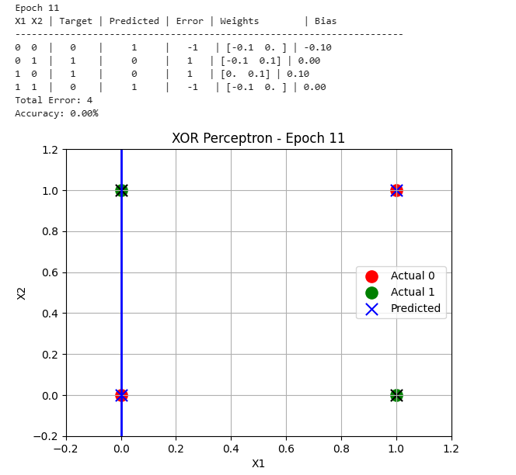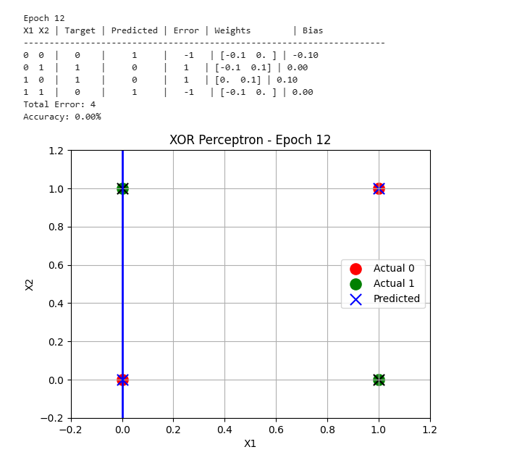
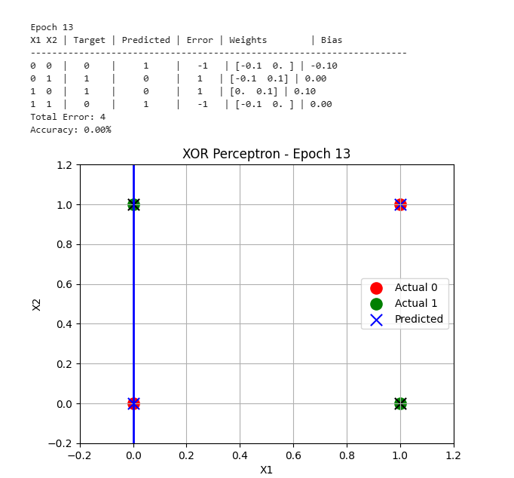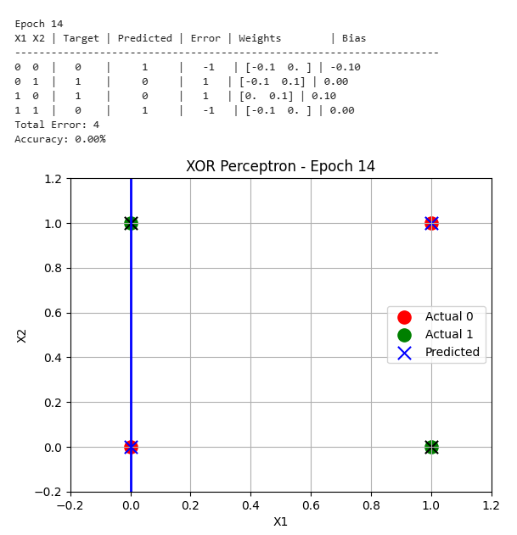
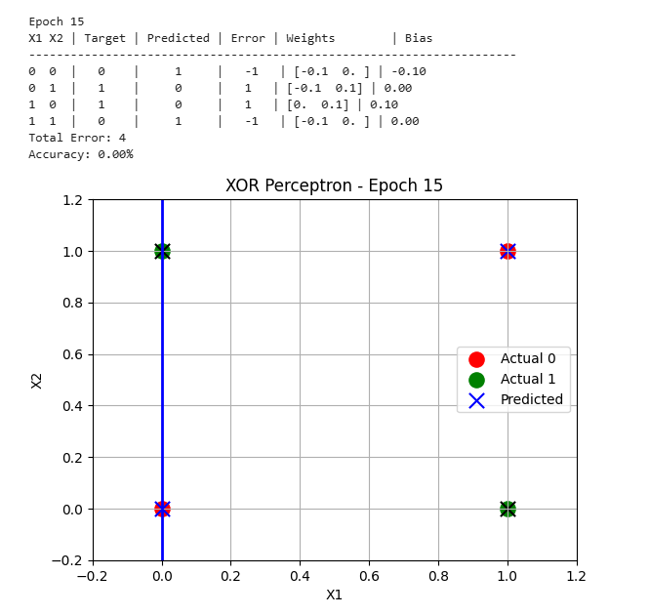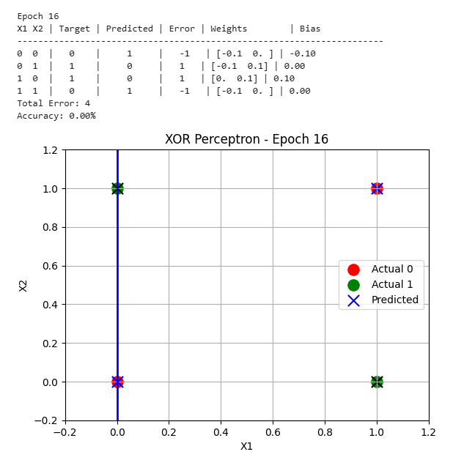
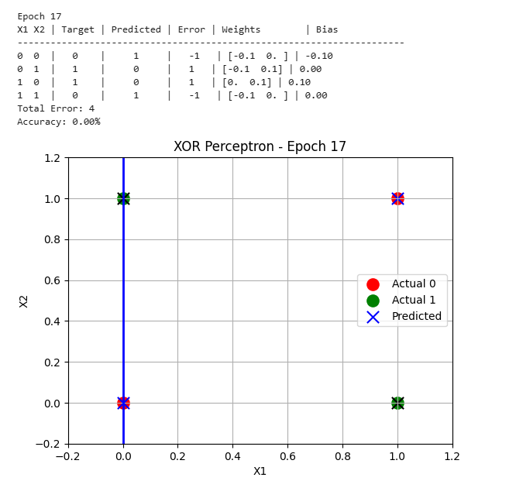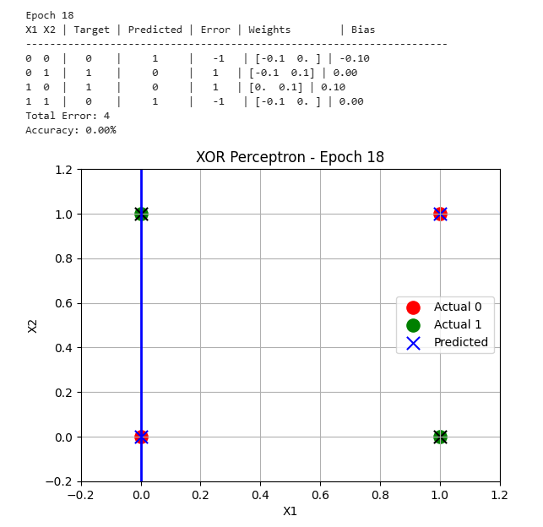

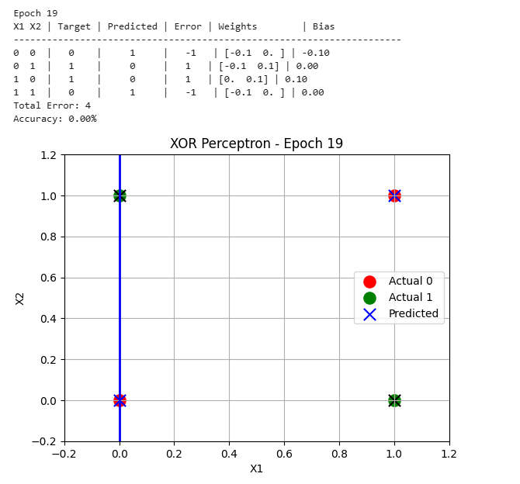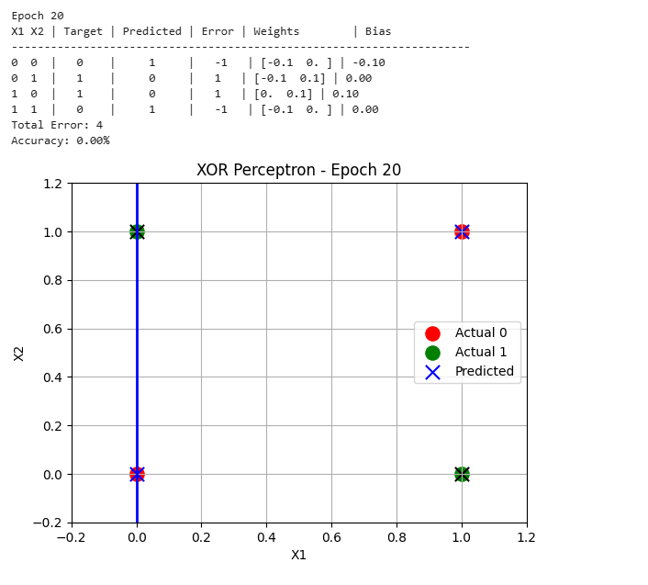
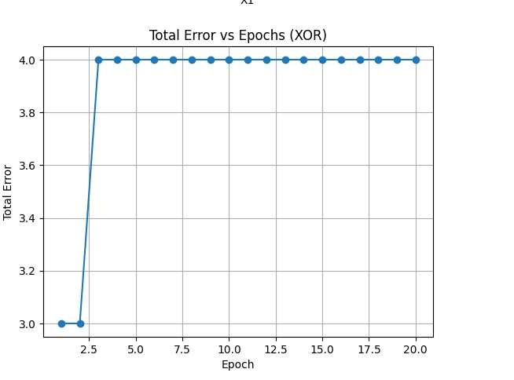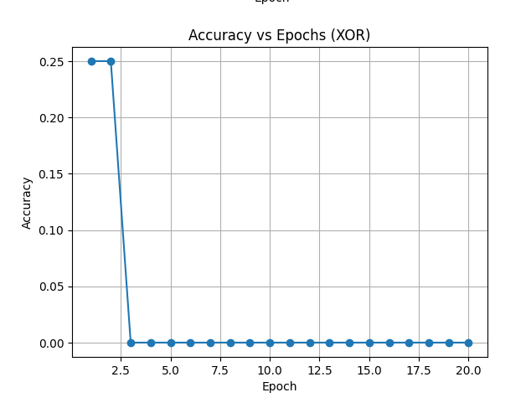
#comments :
What I learned from this code:
From XOR code I have learn how a single layer perceptron behave when we try to solve the problem of XOR the XOR logic is that when the input is different the output is one and when they are same the output is 0 and I also used the step activation to make prediction

Problems I faced:
The major problem in this code I faced was that after increase the epochs the model accuracy is not 100 percent and the decision boundary kept changing but some point classified incorrect in many of time in my code even I have rectified my code many time than I understand that XOR is not a linearly separable

